**AADHAAR BASED ONLINE VOTING SYSTEM**

A PROJECT REPORT

SUBMITTED BY

|  |  |  |  |
| --- | --- | --- | --- |
| **B. NIKITHA** | **(16R91A0508)** |  |  |
| **G. KAMAL YESHODHAR SHASTRY** | **(16R91A0522)** |  |  |
| **S. SAI KUMAR** | **(16R91A0557)** |  |  |

AT

**ECIL-ECIT**

**(ELECTRONIC CORPORATION OF INDIA LIMITED)**

UNDER THE ESTIMATED GUIDANCE OF

**Mr. L. VASUDEVA MURTHY (Head, CED)**

**BACHELOR OF TECHNOLOGY**

IN

**COMPUTER SCIENCE ENGINEERING**



**TEEGALA KRISHNA REDDY ENGINEERING COLLEGE**

**MEDBOWLI, MEERPET, SAROORNAGAR, HYDERABAD**

**(AFFILIATED TO JNTUH)**

**ACKNOWLEDGEMENT**

We wish to take this opportunity to express our deep gratitude to all the people who have extended their cooperation in various ways during our project work. It’s our pleasure to acknowledge the help of all those individuals.

We would like to thank **Mr. L. VASUDEVA MURTHY** and our project guide Mrs. **A**. **RESHMA RANI** for guidance and help throughout development of this project work by providing us with required information. Without her guidance, cooperation and encouragement, we couldn’t learn many new things during our project tenure.

We would like to thank **Mrs. P. ASHWINI REDDY** (**HOD, CSE DEPT**) for her encouragement and valuable guidance in bringing shape to dissertation.

**B. NIKITHA (16R91A0508)**

**G. KAMAL YESHODHAR SHASTRY (16R91A0522)**

**S. SAI KUMAR (16R91A0557)**

**DECLARATION**

We hereby declare that the project entitled “**AADHAAR BASED ONLINE VOTING SYSTEM**” is submitted for the B. Tech in **COMPUTER SCIENCE ENGINEERING**. This dissertation is our original work and the project has not formed the basis for the award of any degree, associateship, fellowship or any other similar titles and no part of it has been published or sent for the publication at the time of submission.

**B. NIKITHA (16R91A0508)**

**G. KAMAL YESHODHAR SHASTRY (16R91A0522)**

**S. SAI KUMAR (16R91A0557)**

**CONTENTS**

**1. INTRODUCTION**6

1.1 ABSTRACT6

**2. ORGANISATION PROFILE8**

**3. PROBLEM DEFINITION10**

**4. SYSTEM ANALYSIS11**

4.1 EXISTING SYSTEM11

4.2 PROPOSED SYSTEM11

**5. FEASIBILITY STUDY12**

5.1 TYPES OF FEASIBILITY STUDY12

**6. PROJECT OVERVIEW**1**4**

6.1 AUTHENTICATION AND SECURITY MODULE14

6.2 ADMIN MODULE14

6.3 CANDIDATES MODULE14

6.4 USER MODULE15

6.5 REPORTS MODULE15

**7. DEFINITIONS, ACRONYMS, ABBREVIATIONS16**

**8. SYSTEM REQUIREMENTS17**

8.1 HARDWARE REQUIREMENTS17

8.2 SOFTWARE REQUIREMENTS17

**9. TECHNOLOGIES18**

9.1 JAVA18

9.2 JAVA SERVER PAGES(JSP)19

9.3 JDBC19

9.4 MYSQL21

**10.SYSTEM DESIGN22**

**11.SCREENSHOTS27**

**12.DATABASE DESIGN32**

**13.TEST PROFILE, TEST PLAN34**

**14.CONCLUSION37**

**12. BIBLIOGRAPHY38**

# 1: INTRODUCTION

**1.1 ABSTRACT: -**

**TITLE OF PROJECT: AADHAAR BASED ONLINE VOTING SYSTEM**

**Introduction**:

Aadhar based online voting system is developed for Indian elections. The proposed model has a greater security in the sense that voter high security password is confirmed before the vote is accepted in the main database of Election Commission of India. The additional feature of the model is that the voter can confirm if his/her vote has gone to correct candidate/party. In this model a person can also vote from outside of his/her allotted constituency or from his/her preferred location. In the proposed system the tallying of the votes will be done automatically, thus saving a huge time and enabling Election Commissioner of India to announce the result within a very short period.

**MODULES DESCRIPTION**

The system after careful analysis has been identified to be presented with the following modules:

The Modules involved are

1. Authentication and Security Module

2. Admin

3. Candidates

4. Users

5. Reports

**Authentication and Security Module:**

User/ Political parties should register should register here for getting login permissions. Admin will verify the details and accept or reject the user/Political parties. Once admin accept the user/political party registration then only they can login.

**Admin Module**

Admin can login to the system by default user name and password then he can change the login credentials. Admin can accept or reject the users and political parties. Admin can view the list of parties and users. Admin has to announce the election dates and results. Admin has to maintain previous records and generate reports based on previous records.

**Candidates Module**

Candidates have to enroll them self with party name, name, age, gender etc. Candidates can view other registered candidates. Candidates can login after admin acceptance only.

**User Module**

Users have to enroll them self with name, mobile, email, address, Aadhar number etc. Once admin accepts the registration users can login into system and they can view list of parties. They can vote. Users can change the passwords and update the profile. They can view election results.

**Reports Module**

Generally, all users of the system are interested in viewing various reports. This module

is concerned in generating the reports of their choice. Reports will be generated by

admin.

# 2: ORGANIZATION PROFILE

**NAME OF THE ORGANIZATION:** ELECTRONICS CORPORATION OF INDIA

LIMITED

Website: http://www.ecil.co.in/ecil/

**HISTORY:**

ECIL was setup under the department of Atomic Energy in the year 1967 with a view to generate a strong indigenous capability in the field of professional grade electronic. The initial accent was on self-reliance and ECIL was engaged in the Design Development Manufacture of several products emphasis on three technology lines viz. Computers, control systems and communications. ECIL thus evolved as a multi-product company serving multiple sectors of Indian economy with emphasis on import of country substitution and development of products and services that are of economic and strategic significance to the country.

Electronic Corporation of India Limited (ECIL) entered into collaboration with OSI systems Inc. ([www.osi-systems.com](http://www.osi-systems.com)) and setup a joint venture “ECIL_RAPSICAN LIMITED”. This joint Venture manufacture the equipment’s manufactured by RAPSICAN, U.K, U.S.A with the same state of art Technology, Requisite Technology is supplied by RAPSICAN and the final product is manufactured at ECIL facility.

Recognizing the need for generating the quality IT professional and to meet the growing demand of IT industry, a separate division namely CED has been established to impart quality and professional IT training under the brand name of ECIT. ECIT, the prestigious offshoot of ECIL is an emerging winner and is the fore front of IT education in the country.

**VISION:**

To develop country in achieving self-reliance in strategic electronics**.**

**MISSION:**

ECIL’s mission is to consolidate its status as a valued national asset in the area of strategic electronics with specific focus on Atomic Energy, Defence, Security and such critical sectors of strategic national importance.

**OBJECTIVES:**

To continue services to the country’s needs for the peaceful uses Atomic Energy. Special and Strategic requirements of Defense and Space, Electronics Security and Support for Civil aviation sector.

To establish newer Technology products such as Container Scanning Systems and Explosive Detectors.

To re-engineer the company to become nationality and internationality competitive by paying particular attention to delivery, cost and quality on all its activities.

To explore new avenues of business and work for growth in strategic sectors in addition to working realizing technological solutions for the benefits of society in areas like Agriculture, Education, Health, Power, Transportation, Food, Disaster Management etc.

**DIVISIONS:**

The company is organized into divisions serving various sectors, national and commercial importance. They are Divisions serving nuclear sector like Control And Automation (CAD), Instruments and Systems Divisions (ISD), Divisions Serving defense sector like Communications Division (CND), Antenna Products Division (APD), Servo Systems Division (SSD) etc., Divisions handling Commercial Products are Telecom Division (TCD), Customer Support Division (CSD), Computer Education Division (CED).

**EXPORTS:**

ECIL is currently operating in major business EXPORT segments like instruments and systems design, Industrial/Nuclear, Server Systems, Antenna Products, Communication, Control and Automation and several other components.

**SERVICES:**

The company played a very significant role in the training and growth of high caliber technical and managerial manpower especially in the fields of Computers and Information technology. Though the initial thrust was in meeting the Controls and Instrumentation requirements of the Nuclear Power Program, the expanded scope of self-reliance pursued by ECIL enabled the company to develop various products to cater to the needs of Defense, Civil Aviation, Information and Broadcasting, Telecommunications, etc.

# 3: PROBLEM DEFINITION

The Existing system for Civil Registry maintains the relevant data across the files and ledgers. The concerned authorities must update the data regarding to the government records and Register certificates and send the same to citizens. The authorities must collect the data from various departments and register certificates. The system lacks coordination among the various departments.

The citizens have to apply for the required Government records at the respective offices by filling the appropriate forms. Manual checking for the attested identify proofs is required which consumes much effort and time as different records are handled by different authorities. No particular notification will be provided before the rejection of the form for any cause or reason. Presently all the registrations are done manually.

If a person wants to make registrations like birth, death, marriage etc........ he should directly contact the corresponding office. The main disadvantage is that there will be lot of difficulties for the citizens. So, all these procedures will be a time consuming one. The applications from the users of all are maintained at the single authority where all the verifications will be done. This increase the manual work as the authorities must collect the data from various departments and agencies. Due to this there arise chances of clubbing and misplacement of data which results in mistakes in the certificate issued.

# 4: SYSTEM ANALYSIS

## 4.1 EXISTING SYSTEM:

From 1998, Ballot boxes were replaced by Electronic Voting Machine in India. A Control Unit and a Balloting Unit, these two units is a part of Electronic Voting Machine which is connected by a five-meter cable. The Control Unit is located with the Polling Officer and therefore the Balloting Unit is located inside the voting compartment. Instead of supplying a ballot paper, the Polling Officer can press the Ballot Button. Rather than issuing a ballot paper, the Polling Officer will press the ballot Button. This will allow the voter to cast his vote by means of pressing the blue button on the voting Unit against the candidate and symbol of his choice.

## 4.2 PROPOSED SYSTEM:

Aadhaar based voting system is aimed at developing a web-based system. This system is completely automated. In this system the person can register online and do many things. The details of all the things are made available to them through the single website.

**ADVANTAGES**

1.Peoples can vote without going to their home constituency on the Election Day means they can vote from their current city.

2. Illegal Voting will totally remove because of Fingerprint (a biometric trait which is unique to each individual).

3. Aadhar’s database permits only eligible voters to vote and, it also ensures that eligible voters vote only once.

4. It maintains privacy means authority; ballot officer or anyone else cannot link any ballot to the voter.

5. The major benefit of this system is to increase the voting percentage.

6. It also saves time as well as money of traveling.

7. Quick results are possible.

# 5: FEASIBILITY STUDY

Feasibility study tries to determine whether a given solution will work or not. Its main objective is not to solve the problem, but to acquire its scope. It focuses on following:

* Meet user’s requirements.
* Best utilization of available resources.
* Develop a cost-effective system.
* Develop a technically feasible system.

## 5.1 TYPES OF FEASIBILITY:

The feasibility report of the project holds the advantages and flexibility of the project. This is divided into four sections:

* Technical Feasibility
* Economic Feasibility
* Legal Feasibility
* Operational Feasibility
* Schedule Feasibility

**TECHNICAL FEASIBILITY**

The assessment is based on the outline design of system requirements in terms of Input, Process, Output, Fields, Programs, and Procedures. This can be quantified in terms of volumes of data, trends, frequency of updating, etc. in order to estimate where the new system will perform adequately or not. Technology Feasibility is carried out to determine whether the company has the capability, in terms of software, hardware, personnel and expertise, to handle the completion of project.

**ECONOMIC FEASIBILITY:**

Economic analysis is the most frequently used method for evaluating the effectiveness of the new system. More commonly known as cost/benefit analysis, the procedure is determining the benefits and savings that are expected from a candidate and compare them with costs. If benefits outweigh costs, then the decision is made to design and implement the system.

**LEGAL FEASIBILITY:**

Determines whether the proposed system conflicts with legal requirements, e.g. - a data processing system must comply with the local protection acts.

## 

**OPERATIONAL FEASIBILITY:**

It is a measure of how well a proposed system solves problems, and takes advantage of the opportunity identified during scope definition and how it satisfies the requirements identified in the requirement analysis phase of a system.

**SCHEDULE FEASIBILITY:**

A project will fail if it takes too long to be completed before it is used. Typically, this means estimating how long the system will take to develop and if it can be completed in a given time period using so many methods like payback period. Schedule feasibility is a measure how the responsible the project timetable is.

# 6: PROJECT OVERVIEW

**PROJECT MODULES:**

Aadhar based online voting system is developed for Indian elections. The proposed

model has a greater security in the sense that voter high security password is confirmed

before the vote is accepted in the main database of Election Commission of India. The

additional feature of the model is that the voter can confirm if his/her vote has gone to

correct candidate/party. In this model a person can also vote from outside of his/her

allotted constituency or from his/her preferred location. In the proposed system the

tallying of the votes will be done automatically, thus saving a huge time and enabling

Election Commissioner of India to announce the result within a very short period.

The Modules involved are

1. Authentication and Security Module

2. Admin

3. Candidates

4. Users

**6.1 Authentication and Security Module**

User/ Political parties should register should register here for getting login permissions.

Admin will verify the details and accept or reject the user/Political parties. Once admin

accept the user/political party registration then only they can login.

**6.2 Admin Module**

Admin can login to the system by default user name and password then he can change the

login credentials. Admin can accept or reject the users and political parties. Admin can

view the list of parties and users. Admin has to announce the election dates and results.

Admin has to maintain previous records and generate reports based on previous records.

**6.3 Candidates Module**

Candidates have to enroll them self with party name, name, age, gender etc. Candidates can view other registered candidates. Candidates can login after admin acceptance only.

**6.4 User Module**

Users have to enroll them self with name, mobile, email, address, Aadhar number etc.

Once admin accepts the registration users can login into system and they can view list of

parties. They can vote. Users can change the passwords and update the profile. They can

view election results.

**6.5 Reports Module**

Generally, all users of the system are interested in viewing various reports. This module

is concerned in generating the reports of their choice. Reports will be generated by

admin.

# 7: DEFINITIONS, ACRONYMS, ABBREVIATION

**HTTP:**

Hyper Text Transfer Protocol is a transaction-oriented client server protocol between

the browser and a web server.

**HTML:**

Hyper Text Markup Language is a programming platform- part of the Java platform- for

developing and running distributed multi-tier architecture Java applications, based largely on

modular software components running on an application server.

**JDBC:**

Java Data Base Connectivity which is used to connect the databases with the java.

**DBMS:**

Data Base Management System which is used to store information. We can retrieve

information from the records in the form of the queries.

**JSP:**

Java Server Pages is a Java technology that helps software developers serve dynamically

generated web pages based on HTML.

# 8: SYSTEM REQUIREMENTS

**SOFTWARE REQUIREMENTS:**

|  |  |  |
| --- | --- | --- |
| Operating System | : | Microsoft Windows 7 or above |
| Technology | : | Java/J2EE (Servlets, JDBC, JSP) |
| Web Technologies | : | HTML, CSS, JavaScript |
| Web Server | : | Apache Tomcat 7.0 |
| Database | : | MySQL |
| Software | : | JDK 1.7 |

**HARDWARE REQUIREMENTS:**

|  |  |  |
| --- | --- | --- |
| Processor | : | Pentium based systems with a minimum of P4 |
| RAM | : | 512 MB or more |

**9. TECHNOLOGIES**

**TECHNOLOGIES**

Front End or User Interface Design:

The entire user interface is planned to be developed in browser specific environment with

touch of intranet-based architecture for achieving the distributed concept.

The browser specific components are designed using the html standards and dynamism of

the designed by concentrating on the constructs of the java server pages.

**Communication or Database Connectivity Tier:**

The communications architecture is designed by concentrating on the standards of

servlets, and enterprise Java Beans. The database connectivity is established using Java

database connectivity.

The standards of three tier architecture are given major concentrations to keep the standards

of higher cohesion and limited coupling for effectiveness of the operations.

**Languages Used:**

In our project, we have chosen Java language for developing the code.

**Java:**

Java is a programming language originally developed by James Gosling at Sun Micro

Systems and released in 1995 as a core component of Sun Micro Systems as a java platform.

The language derives much of its syntax from C and C++ but has a simpler object model and

fewer low-level facilities. Java applications are typically complied to byte code that can run

on any java virtual machine regardless of computer architecture.

The original and reference implementation java compliers, virtual machines and class

libraries were developed by Sun from 1995. As of May 2007, in complains with the

specification of the java communication process, Sun relicense most of its java technologies

under the GNU General Public License.

**Principles:**

There were five primary goals in creations of the java language. It should be simple,

object-oriented, and familiar.

1. It should be robust and secure

2. It should be architecture neutral and portable

3. It should execute with high performance

4. It should be interpreted and dynamic

**Syntax:**

The syntax of java is largely derived from C++. Unlike C++ which combines from

structure, generic and object-oriented programming. Java was built almost exclusively as an

object-oriented language. All code is written in a class and everything is object with the

exception of intrinsic data type, which is a not cause for performance reasons.

Java suppresses several features for classes in order to simplify the language and to

prevent possible errors anti pattern design.

**JSP (JAVA SERVER PAGES)**

Java Server Pages (JSP) is a Java technology that allows software developers to dynamically

generate HTML, XML or other types of documents in response to a Web client request. The

technology allows Java code and certain pre-defined actions to be embedded into static

content.

The JSP syntax adds additional XML-like tags, called JSP actions, to be used to invoke built-

in functionality. Additionally, the technology allows for the creation of JSP tag libraries that

act as extensions to the standard HTML or XML tags. Tag libraries provide a platform

independent way of extending the capabilities of a Web server.

JSPs are compiled into Java Servlets by a JSP compiler. A JSP compiler may generate a

servlet in Java code that is then compiled by the Java compiler, or it may generate byte code

for the servlet directly. JSPs can also be interpreted on-the-fly reducing the time taken to

reload changes.

Java Server Pages (JSP) technology provides a simplified, fast way to create dynamic web

content. JSP technology enables rapid development of web-based applications that are server-

and platform independent.

**JDBC**

JDBC (Java Database Connectivity) is an API developed by Sun Microsystems that provides

a standard way to access data using the Java programming language. Using JDBC, an

application can access a variety of databases and run on any platform with a Java Virtual

Machine.

It isn’t necessary to write separate applications to access different database systems (Oracle and Sybase, for example). Using JDBC allows you to write one application that can send SQL statements to different database systems. SQL is the standard language for accessing relational databases.

The JDBC API defines a set of Java interfaces that encapsulate major database functionality,

such as running queries, processing results, and determining configuration information.

Because JDBC applications are written in Java, applications work on any platform.

The JDBC API makes it possible to do three things:

Establish a connection with a database or access any tabular data source

Send SQL statements-

Process the results

**JDBC DRIVERS:**

Today, there are four types of JDBC drivers in use:

Type 1: JDBC-ODBC bridge

Type 2: partial Java driver

Type 3: pure Java driver for database middleware

Type 4: pure Java driver for direct-to-database

In this project we are using Type 1 driver which provides best database connectivity

for internet-based application.

**Type 1 JDBC Driver**

**JDBC-ODBC Bridge driver**

The Type 1 driver translates all JDBC calls into ODBC calls and sends them to the ODBC

driver. ODBC is a generic API. The JDBC - ODBC Bridge driver is recommended only for

experimental use or when no other alternative is available.

Advantage:

The JDBC-ODBC Bridge allows access to almost any database, since the database&#39;s ODBC

drivers are already available.

Disadvantages:

1. Since the Bridge driver is not written fully in Java, Type 1 drivers are not portable.

2. A performance issue is seen as a JDBC call goes through the bridge to the ODBC driver,

then to the database, and this applies even in the reverse process. They are the slowest of all

driver types.

3. The client system requires the ODBC Installation to use the driver.

4. Not good for the Web.

**MySQL**

The database which we are using is the MYSQL database. It’s an open source and easily

manageable, and is very much compatible with Java.

MySQL is open source database in LAMP - the software platform comprised of

Linux, Apache, MySQL and PHP/Perl often viewed as the foundation of the Internet. Sun is

committed to enhancing and optimizing the LAMP stack on GNU/Linux and Microsoft

Windows along with Open Solaris and MAC OS X. The database from MySQL, Open

Solaris and Glassfish, together with Sun in Java platform and Net Beans communities, will create a powerful Web application platform across a wide range of customers shifting their applications to the Web.

More than 100 million copies of MySQL high-performance open source database software have been downloaded and distributed and an additional 50,000 copies are downloaded daily.

This broad penetration coupled with MySQL strength in Web 2.0, Software as a Service, enterprise, telecom and the OEM embedded market make it an important fit for Sun. With MySQL, Sun will have the ability to deepen its existing customer relationships and create new opportunities with companies seeking the flexibility and ease-of-use of open source systems.

# 

# 10: SYSTEM DESIGN

**UML DIAGRAMS**

**CLASS DIAGRAM**

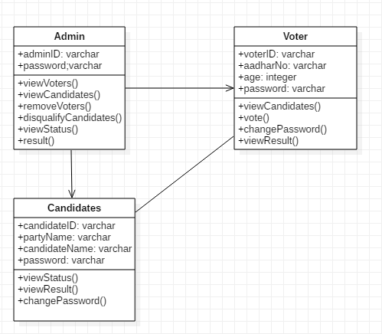

**SEQUENCE DIAGRAM:**

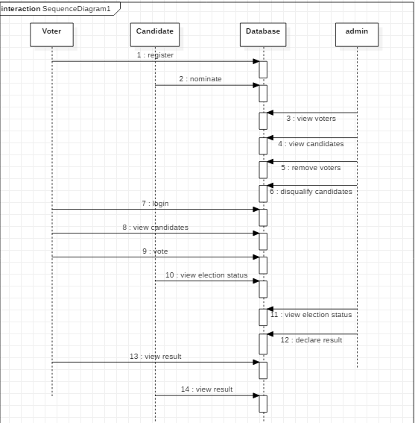

**USECASE DIAGRAM OF USER:**

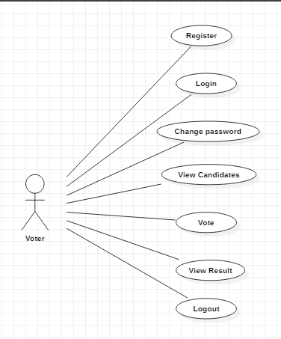

**USECASE FOR CANDIDATE:**

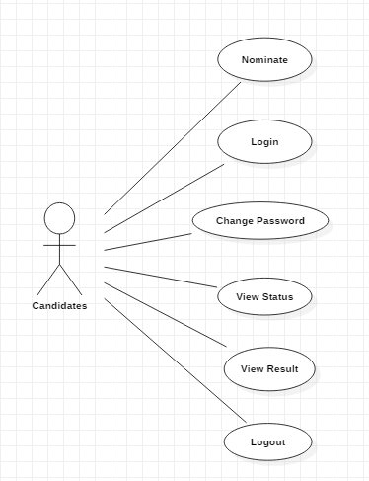

**USECASE FOR ADMIN:**

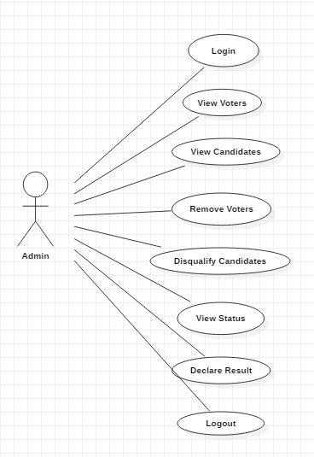

# 11: SCREEN SHOTS

# HOME PAGE:

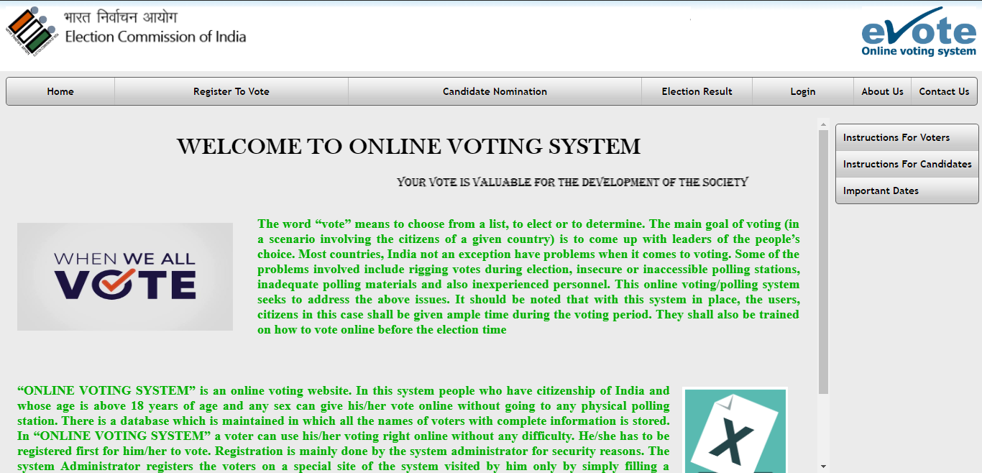

**USER HOME PAGE:**

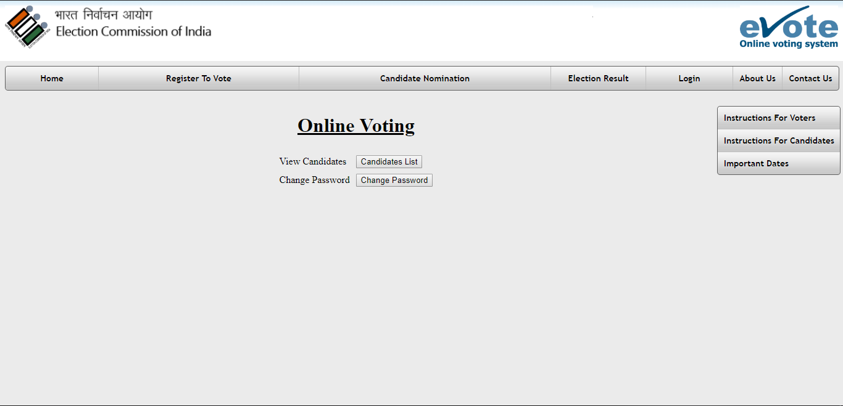

**CANDIDATE HOME PAGE:**

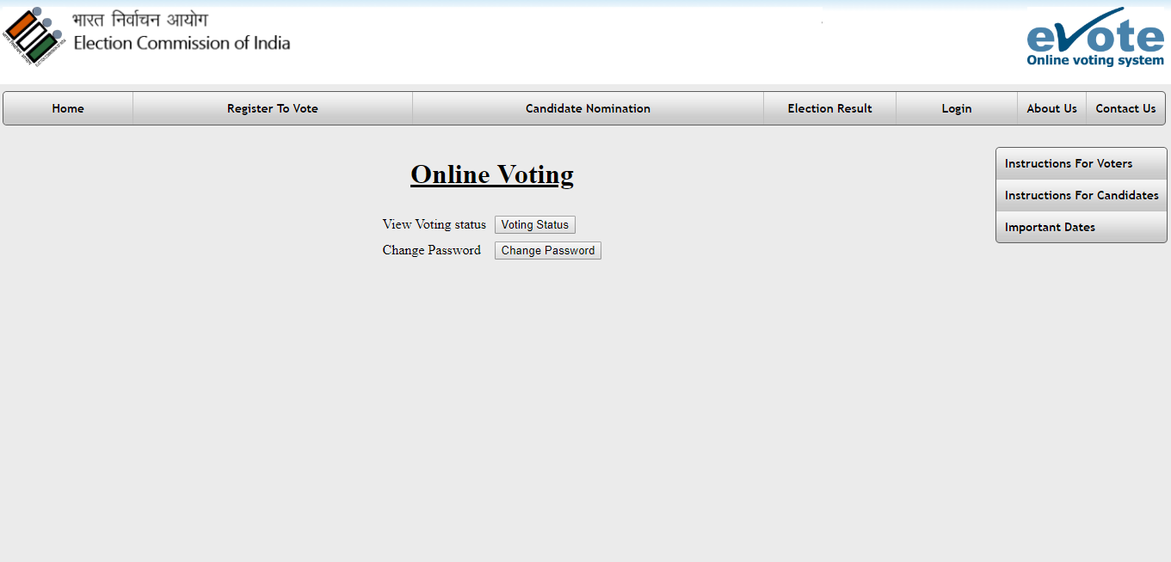

**ADMIN HOME PAGE:**

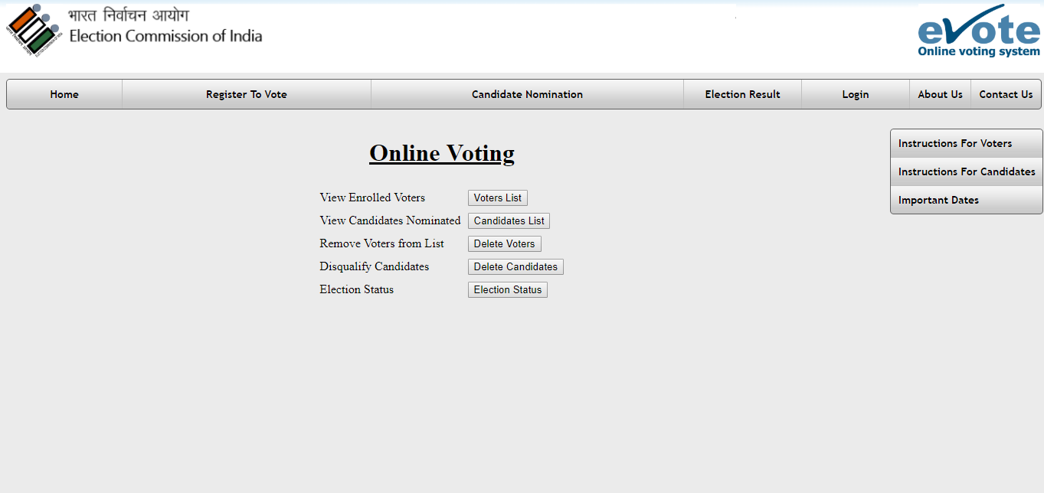

**CANDIDATES LIST:**

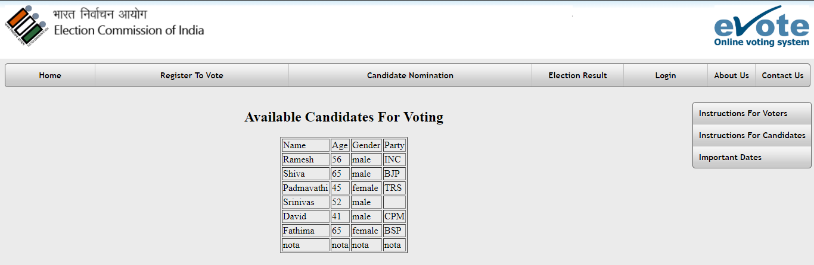

**VOTING PAGE**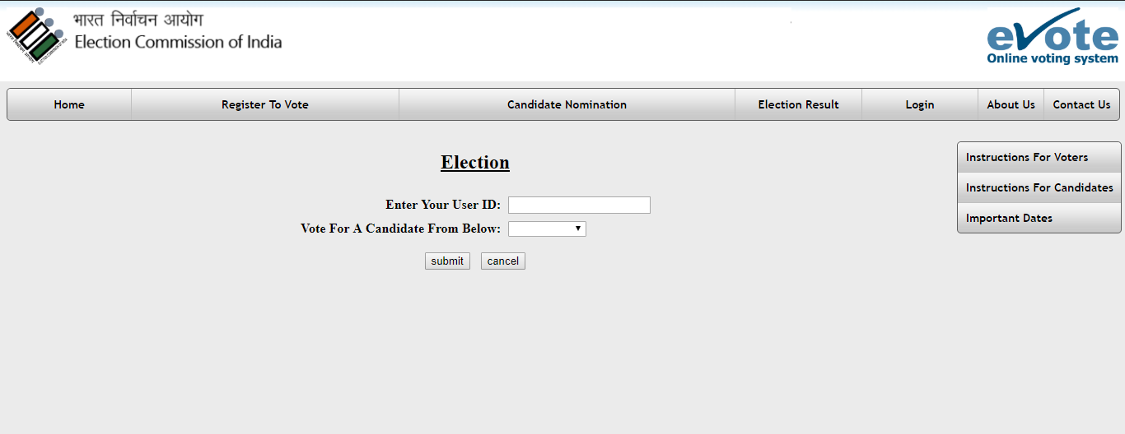

**VOTE ACKNOWLEDGEMENT PAGE:**

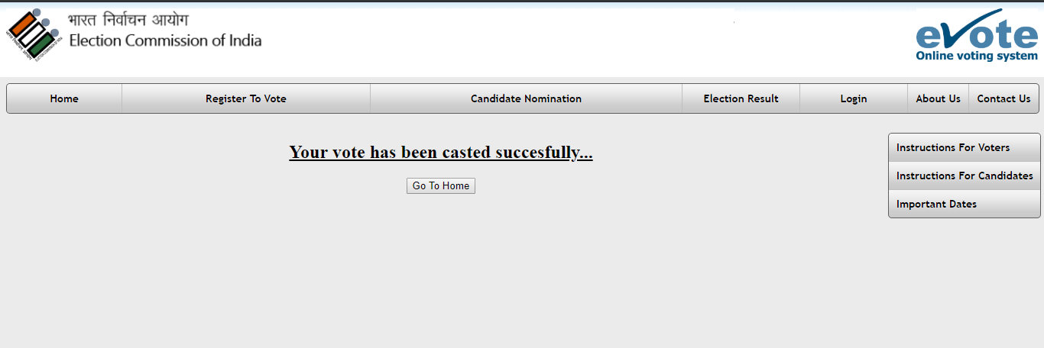

**VOTING STATUS PAGE:**

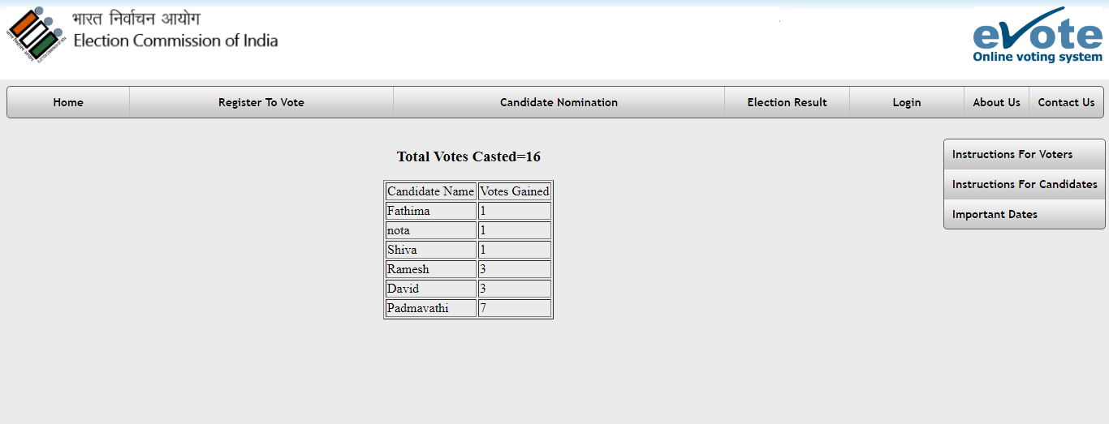

**FINAL RESULTS:**

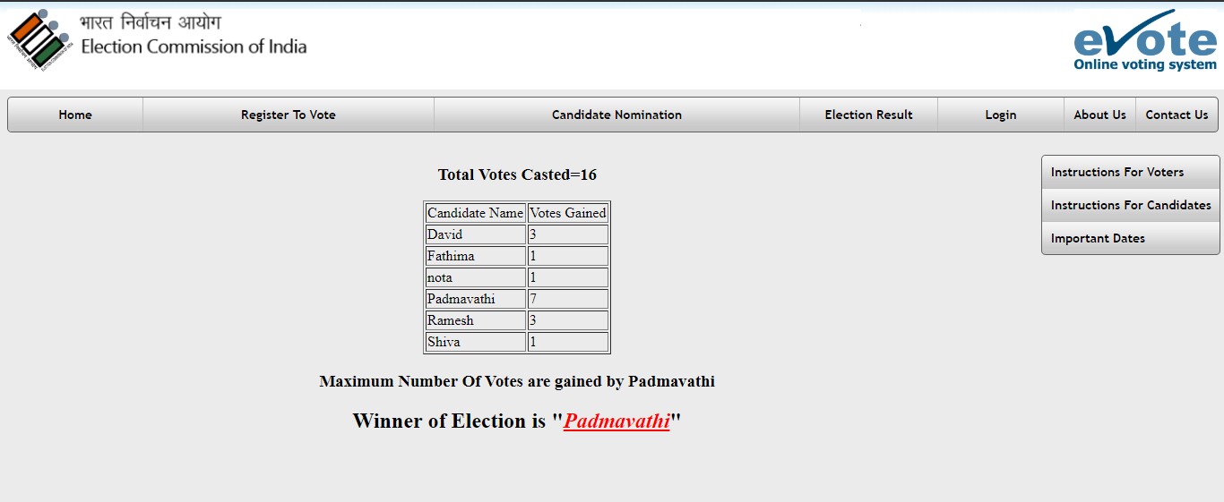

**CHANGE PASSWORD:**

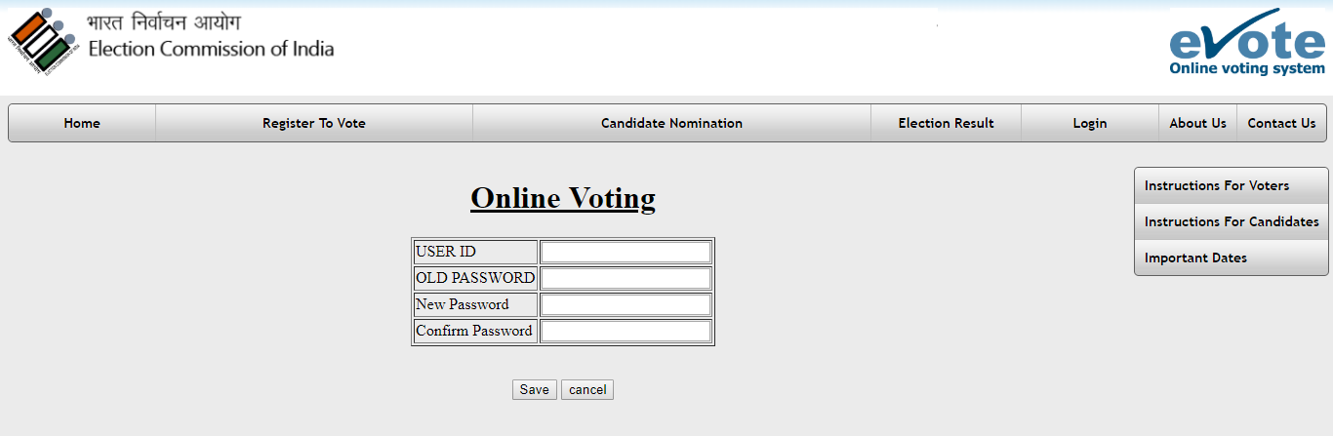

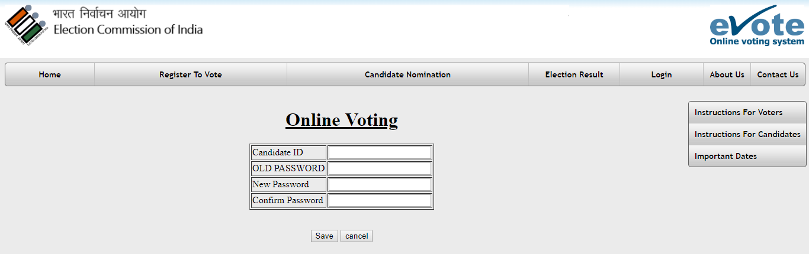

**DISQUALIFY CANDIDATES:**

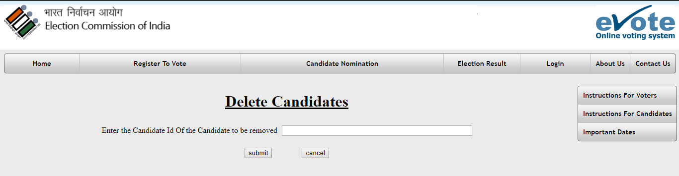

**REMOVE VOTER:**

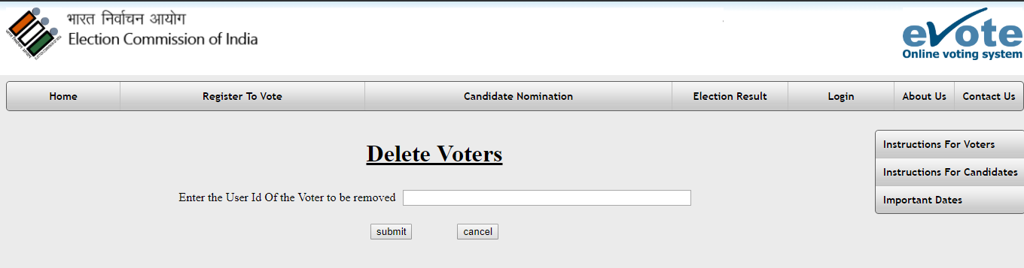

# 12: DATABASE DESIGN

**DATABASE TABLES:**

***USER REGISTRATION***

|  |  |  |
| --- | --- | --- |
| **FIELD NAME** | **DATA TYPE** | **Key** |
| fname | Varchar |  |
| lname | Varchar |  |
| age | Varchar |  |
| gen | Varchar |  |
| aadhar | Varchar |  |
| address | Varchar |  |
| city | Varchar |  |
| state | Varchar |  |
| pincode | Integer |  |
| mobno | Varchar |  |
| email | Varchar |  |
| uid | Varchar | Primary key |
| pwd | Varchar |  |

***REGISTER CANDIDATES***

|  |  |  |
| --- | --- | --- |
| **FIELD NAME** | **DATA TYPE** | **Key** |
| name | Varchar |  |
| age | Varchar |  |
| gen | Varchar |  |
| address | Varchar |  |
| city | Varchar |  |
| state | Varchar |  |
| pincode | Integer |  |
| mobno | Varchar |  |
| email | Varchar |  |
| party | Varchar |  |
| cid | Varchar | Primary key |
| pwd | Varchar |  |

***VOTING COUNT***

|  |  |  |
| --- | --- | --- |
| **Field Name** | **Data Type** | **Key** |
| uid | Varchar | Primary key/Foreign key: user_reg(uid) |
| name | Varchar |  |

.

**13: TEST REPORT AND TEST PLAN**

Software testing is an investigation conducted to provide stakeholders with information about

the quality of the product or service under test. Software testing also provides an objective,

independent view of the software to allow the business to appreciate and understand the risks

of software implementation. Test techniques include, but are not limited to, the process of

executing a program or application with the intent of finding software bugs (errors or other

defects).

Software testing can also be stated as the process of validating and verifying that a software

program / application / product:

Meets the business and technical requirements that guided its design development;

1. Works as expected; and

2. Can be implemented with the same characteristics.

Software testing, depending on testing method employed, can be implemented at any

time in development process. However, most of the test effort occurs after the

requirements have been defined and coding process has been completed. As such, the

methodology of the justice governed by the software development methodology adopted.

Different software development models will focus the test effort at different points in

development process. Newer development process such as Agile, often employee test

driven development and place an increased portion of the testing in hands of developer

before it reaches a formal team of tester. In a more traditional model, most of the test

execution occurs after the requirements have been defined and the coding process has

been completed.

TEST REPORT:

1. PROJECT NAME: AADHAAR BASED VOTING SYSTEM

2. FORM NAME: USER LOGIN

3. UNIT NAME: Username, password, Aadhar number

4. TEST RESULT: After entering two fields the user successfully logs into the

system.

TEST PLAN 1:

Unit id: Login

Test case id: Username

Test Type: Unit Testing

Form Name: Login

Base Table: users

Purpose: To give access to user after he enters valid user id

Description: Username varchar (20), Primary Key.

TEST DATE:

|  |  |  |  |
| --- | --- | --- | --- |
| S.NO | Input | Excepted output | Results |
| 1. | Column Name:  Username:  Invalid Input | Login-Success  Screen  Error Message | Login-in  Success  Screen  Login Page |

TESTPLAN 2

Unit id: poll

Test case id: Aadhaar number

Test Type: Unit Testing

Form Name: Poll

Base Table: Candidates

Purpose: To vote for the candidates who are standing.

Description: Keyword varchar (20), Primary Key.

|  |  |  |  |
| --- | --- | --- | --- |
| S.NO | Input | Excepted output | Results |
| 1 | Column Name:  Keyword:  Invalid Input | Thankyou page  Error Message | Thankyou page  Error Message |

# 14: CONCLUSION

Online Voting Systems have many advantages over the traditional voting system. Some of these advantages are less cost, faster generation results, easy accessibility, accuracy, and low risk of human and mechanical errors. It is very difficult to develop online voting system which can allow security and privacy on the high level. Future development focused to design a system which can be easy to use and will provide security and privacy of votes on acceptable level by proper authentication and processing section. It is easy to use and it is less time consuming. It is very easy to debug.

# 15: BIBLIOGRAPHY

# JAVA USER SITE: www.java.com

# JAVA SPECIFICATIONS: 2 Ed.Java.Sun.com

# JAVA UPGRADES GUIDE: migration from Microsoft VM for java to sun

# JRE: java.sun.com

# JAVA VIRTUAL MACHINE: Wikipedia

# http://en.wikipedia.org/wiki/javaserver_pages

# http://en.wikipedia.org/wiki/java_database_connectivity

# http://en.wikipedia.org/wiki/javaserver

# http://www.ecil.co.in

# http://www.ecil.gov.in